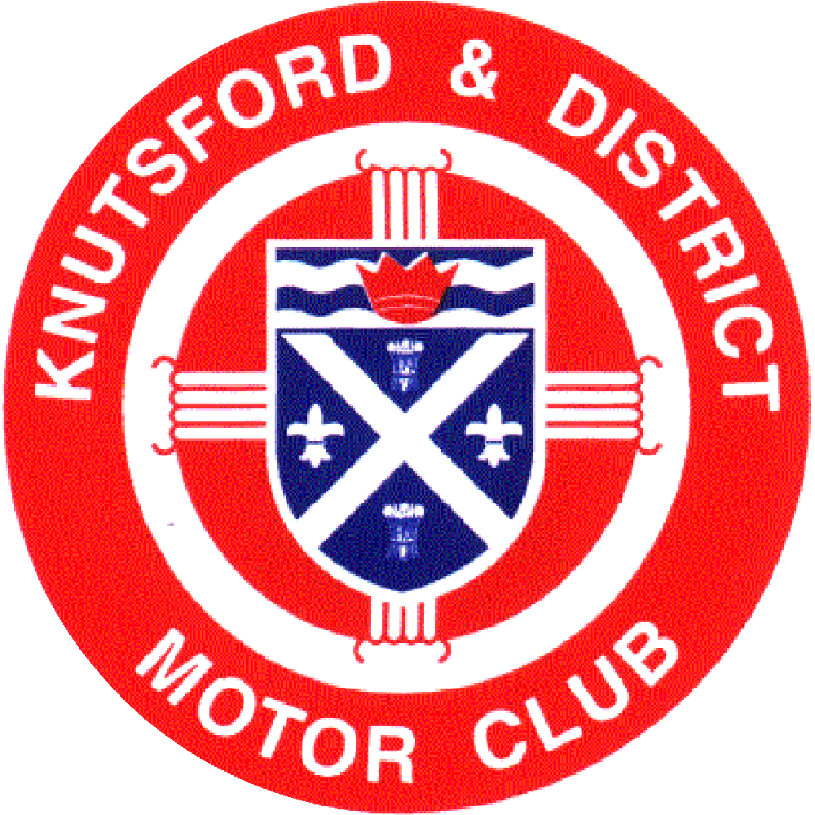

SAFEGUARDING POLICY

Policy No; KDMC /004

Issue Number: A | Reason for issue. New Doc
Rev Final
Approved Date: 10/01/24  Issue Date Jan 2024 | Secretary : J Gray

SAFEGUARDING POLICY

The welfare of all children and vulnerable adults is paramount. Everyone, whatever their age, gender, ability or disability, race, faith, culture, size, shape, language, or sexual identity have the right to be protected from abuse, or harm.
Knutsford & District Motor Club (The Club) is committed to safeguarding the wellbeing of all off its members, and those individuals involved in events it organises.
Club members are required to uphold The Club’s Safeguarding Policy, as set out below, and those of its governing body, MotorSport UK.
All members are expected to show respect to others they interact with during any of The Club’s activities, be they competitive or social events or in connection with the management activities of The Club. They should understand the rights of any individual, their welfare needs and ensure participation in Club activities can be undertaken safely.

1. The Club will adhere to the Safeguarding Policy of MotorSport UK

2. The Club acknowledges a responsibility for the safeguarding the welfare of young and /or vulnerable adults who are involved in any aspects of Club activities.

3. All Club competitive and social events, and other activities, will adhere to the values contained in Motorsport UK’s ‘Race With Respect’ Code.

4. All participants in Club activities regardless of age, gender, ability or disability, race, faith, culture, size, shape, language, or sexual identity have the right to be protected from abuse, or harm. All suspicions and allegations of inappropriate behaviour will be taken seriously and responded to swiftly and appropriately.

5. The Club will appoint at least one Club Safeguarding Officer. They will deal with any issues concerning Safeguarding, and Child Protection. Their identity and contact details will appear in the regulations, programmes, associated paperwork for all competition/social events and will be displayed at all events organised by The Club; on the Club Officials list in the Club Bulletin and at the foot of this document.

6. The Club will follow Motorsport UK guidance and ensure that anyone to be appointed as a Club Safeguarding Officer meets the eligibility criteria for a ‘Disclosure check’ and does not perform in the capacity until a satisfactory check has been completed.

7. The Club will review its Safeguarding Policy at least annually.

If you witness or are aware of any incident where you are concerned the welfare of an individual involved in a Club activity has been put at risk you must inform a Club Safeguarding Officer at the earliest opportunity. If you are not able to contact them and the matter is serious contact should be made with Motorsport UK’s Lead Safeguarding Team 01753 765000 or e mail safeguarding@motorsportuk.org.

The Club’s Safeguarding Officers are:
Mike Timmins
Email: safeguarding@knutsfordmotorclub.co.uk
Phone: 07747 620009

Jenny Lawson
Email: safeguarding@knutsfordmotorclub.co.uk
Phone: 07917 205846

[Final 10 /01/2024]

